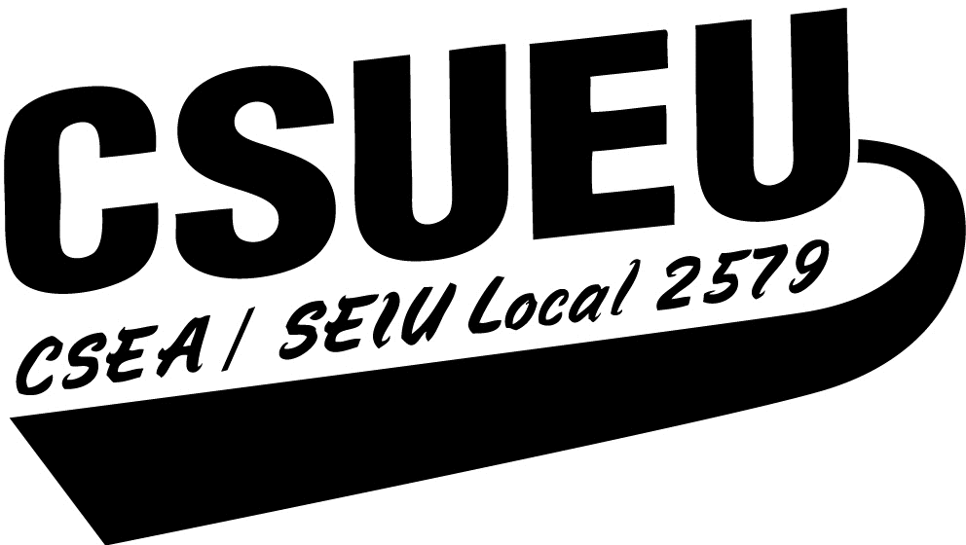

EQUIPMENT ACQUISITION / CHECKOUT AGREEMENT
(for purchases of $200 or more)

CHAPTER :

Acquisition:

Equipment Type: Brand Name:

Model Number: Serial Number:

Accessories Included:

Date Acquired: Cost:

Checkout:

I HEREBY AGREE TO THE FOLLOWING CONDITIONS AND RESTRICTIONS:

- I accept said equipment in good working condition, with all of the accessories as listed above.
- I promise to use said equipment primarily for CSUEU business.
- I promise to use said equipment in a responsible, proper, and safe manner.
- I promise to keep said equipment under my control at all times, and not to release it to, or otherwise allow anyone else to use it for non-Union use.
- I agree to return said equipment at the end of my term of office or upon request by the Chapter Executive Board.
- When said equipment is returned to the Chapter, I shall obtain the date and signature of the person accepting the equipment in the space provided below. I understand that I am not released from responsibility for said equipment until such release is obtained.
- If equipment is damaged, lost or stolen I will immediately notify the Chapter, Chapter Finance and CSUEU Headquarters

Date Checked Out: Checked Out By:

Date Returned: Checked In By:

Return Condition: Items Missing:

Signature:

Name (print): Phone Number: Date:

Chapter Treasurer retains original Checkout Agreement and submits copies to Chapter Finance and CSUEU Headquarters.

