Edit and/or create child site
Once a site has been created for you campus, login and navigate to the site.
- To edit the current page, click on the edit icon (pencil)
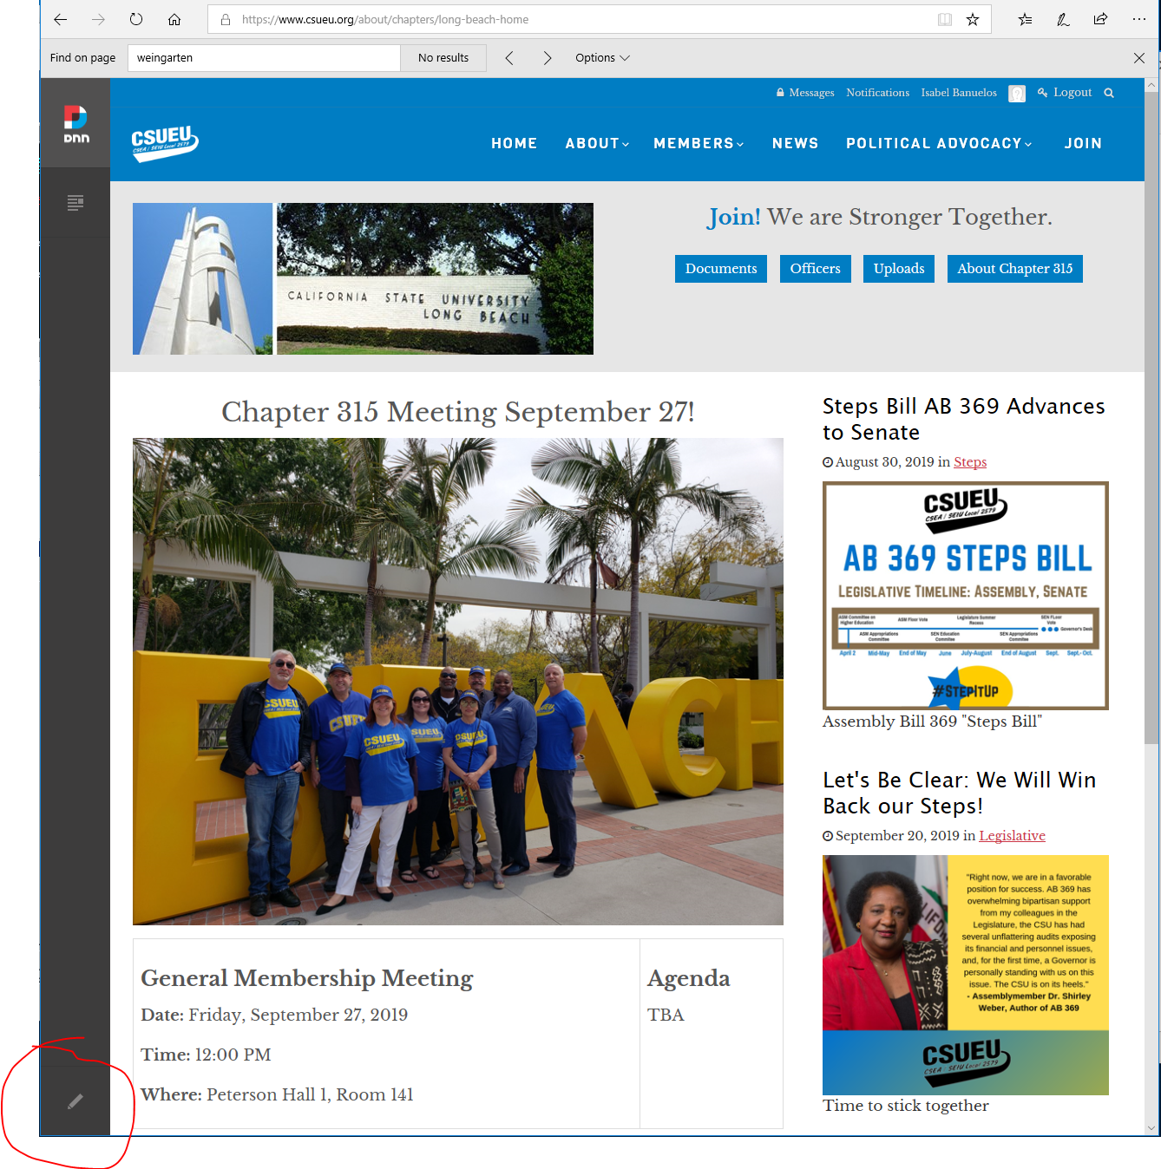
- Here you can add modules as desired. For example, the module showing the next Chapter meeting above is an ‘HTML’ module.
To add a module click on the ‘Add Module’ icon at the bottom of the page.
In the ‘Add Module’ popup search for ‘html’
Chick on the ‘HTML’ module to select it
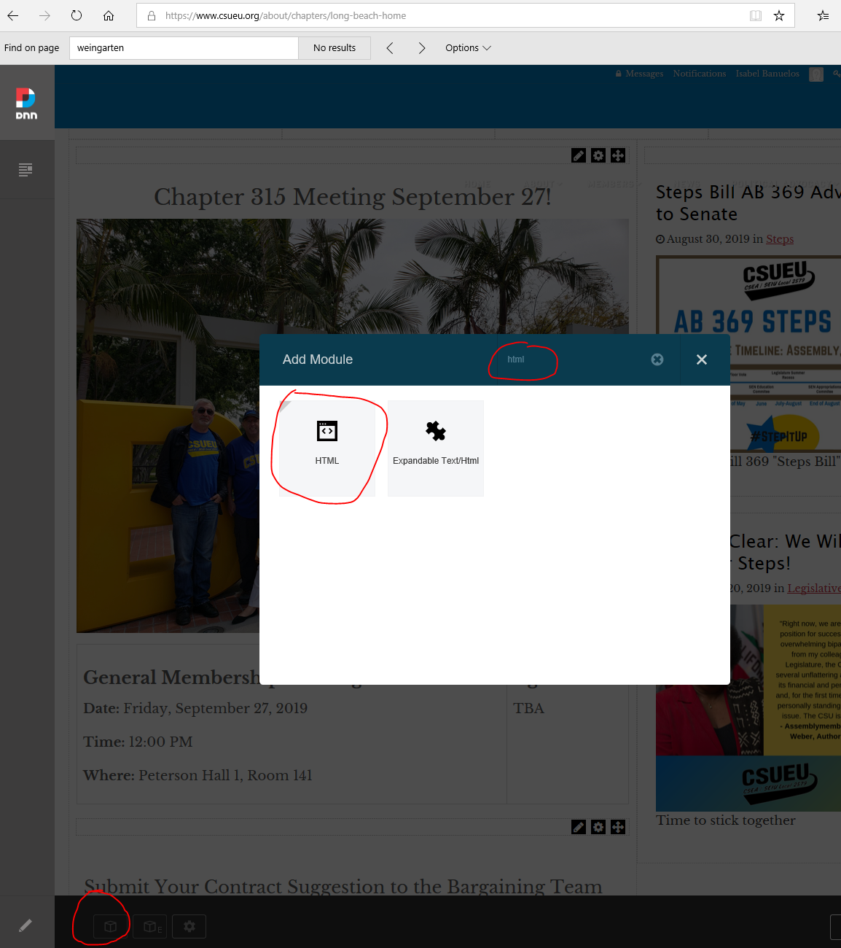
- Drag and drop the module on any of the existing partitions. (partitions that are not populated do not show in your page, so choose a partitions in the location that you want)
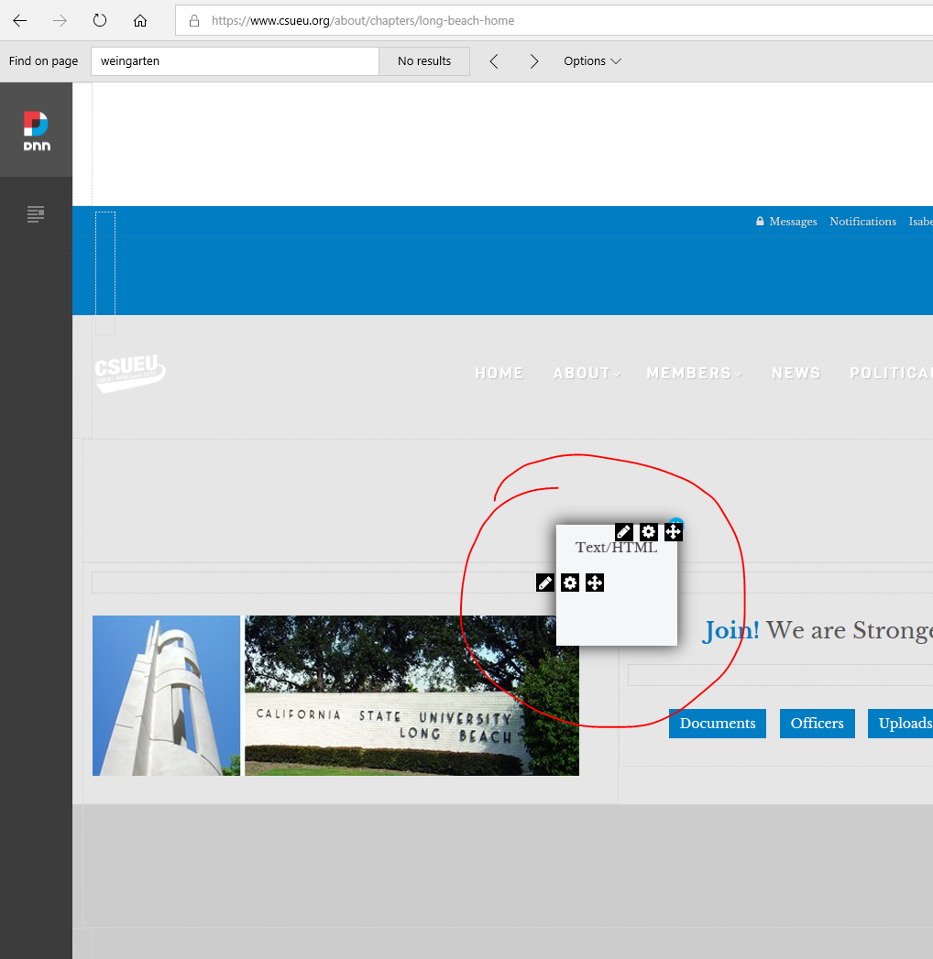
- To edit your newly created module, click on the gear icon and select ‘Settings’
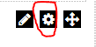
- Under the ‘Module Settings’ tab, enter an appropiate ‘Module Title’
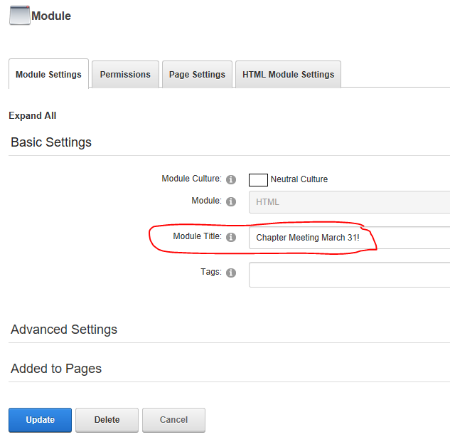
- Set the appropiate permissions under the ‘Permissions’ tab
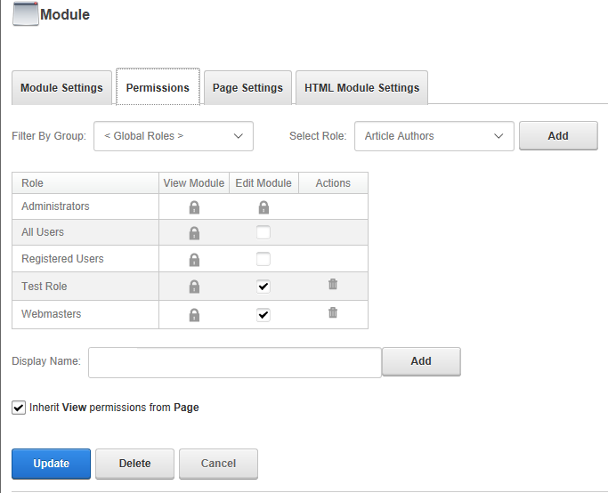
- Under the ‘Page Settings’ tab, in the ‘Module Container’ option select one of the options that start with ‘Host: Generic4 -’
(this will give the same look and feel as the parent page)
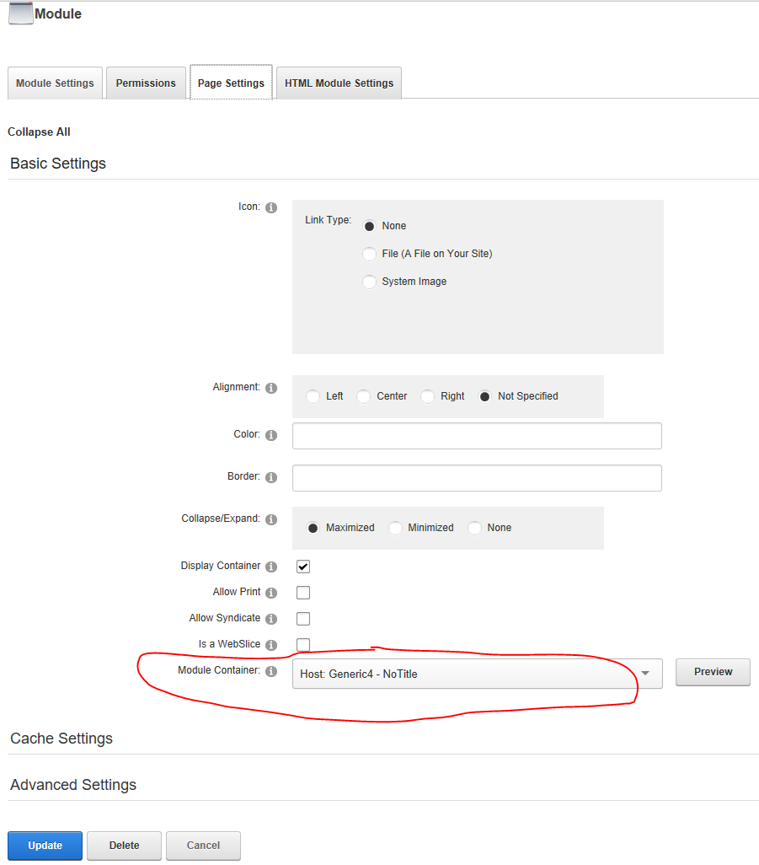
- Click on ‘Update’ to save your changes
- Click on ‘Close’ to get out of edit mode and view your progress
- To add a child page, click on the ‘Content’ icon and select ‘Pages’
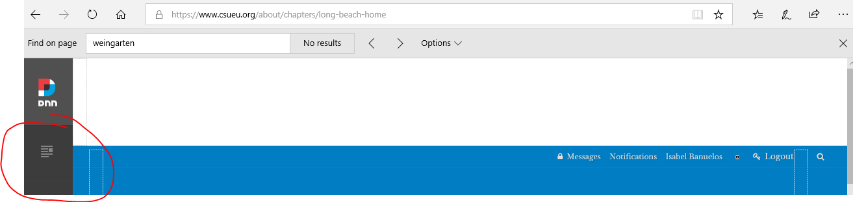
- In the configuration page click ‘Add Page’
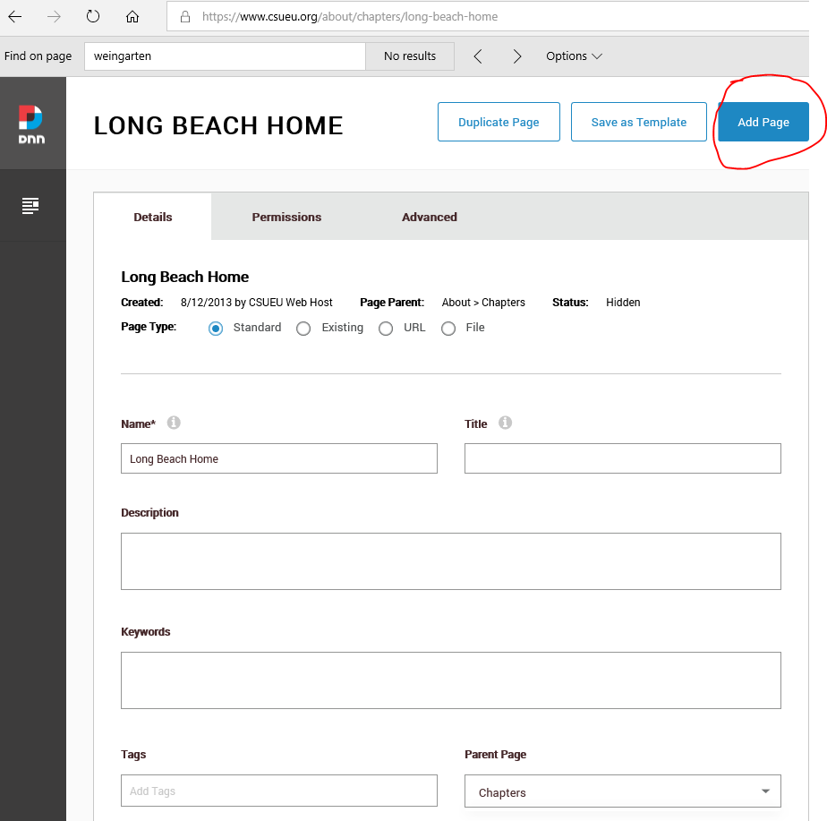

- In the ADD PAGE enter a ‘Name’ for your newly created page
Select the parent page for this page by making a selection from ‘Parent Page’
Notice that as you enter a name, that name is added to the top of the page
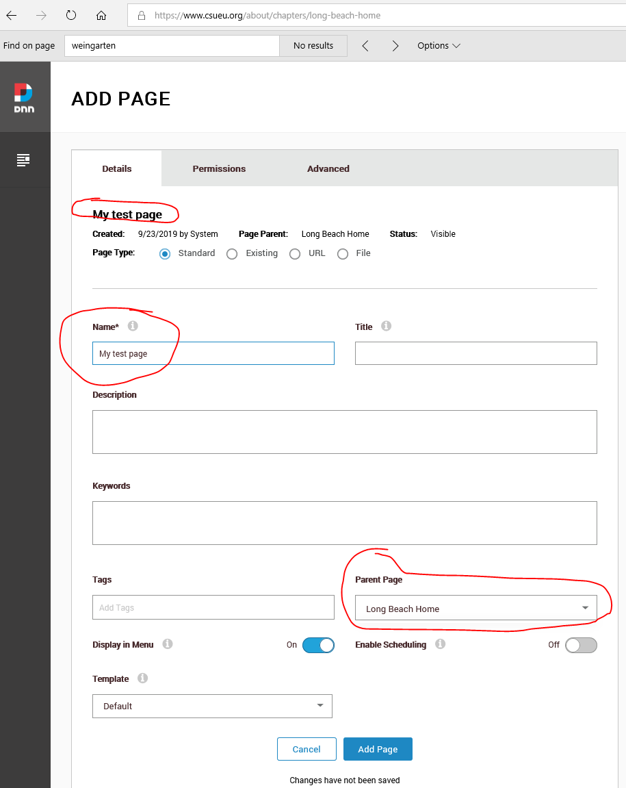

- When a page is allocated to your campus, you should also get a security group, in our case it is ‘315 Editors LB’
In the ‘Permissions’ tab add your campus security group and any other desired permissions. See below for a sample of our page
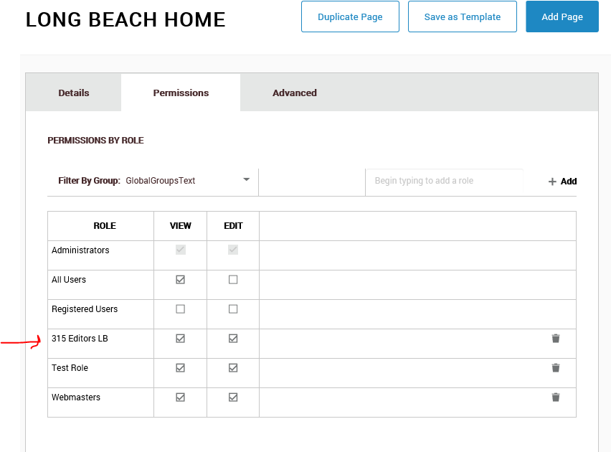
- In the ‘Advanced’ tab click ‘APPEARENCE’ – this will keep the appearance of your page consistent with the parent page.
  - Under ‘Page Theme’ select ‘Generic 4’
  - Under ‘Layout’ select ‘csueu-indexpage’
  - Under ‘Page Container’ select ‘notitle’ - you can play with this one depending on your needs
- Click on the ‘Save’ button to save your newly created page.
- You can find HTML examples for bootstrap version 3.3.7 which is what the CSUEU webpage is using here https://getbootstrap.com/docs/3.4/components/#callout-btn-group-justified-dbl-border
Ex. Source for the HTML module

Looks like this

<h2 style="text-align: center;">Chapter 315 Meeting October TBA!</h2>

<p><img alt="" src="/portals/0/Public_Resources/ChapterContent/315/Images/ch315Officers.jpeg" /></p>

<table class="table table-bordered">
<tbody>
<tr>
<td>
<h3><strong>General Membership Meeting</strong></h3>

<p><strong>Date:</strong> Friday, October TBA, 2019</p>

<p><strong>Time:</strong> 12:00 PM</p>

<p><strong>Where:</strong> TBA</p>
</td>
<td>
<h3><strong>Agenda</strong></h3>

<p>TBA</p>
</td>
</tr>
</tbody>
</table>

